**National University of Computer & Emerging Sciences**

**Department of Computer Science**

# 220 Operating System Lab

**Lab # 04** Shell Scripts

Instructions:

1. **Deadline: February 21, 2020 , 11:40 PM**
2. Make a word document with the convention “SECTION_ROLLNO _LAB-NO”.
3. You have to submit a Word File containing your shell scripts with comments and screenshots of their running outputs.
4. Plagiarism is strictly prohibited, 0 mark would be given to students who cheat.

Objectives:

* Linux Commands
* Shell Scripting
* Practice Problems

Practice Problems:

1. Write a program that defines a function and uses it.
2. Write a program that passes parameters to the function.
3. Write a program that returns a value.
4. Write a program that defines a recursive function.
5. Write a program that uses 1D array.
6. Write a program that uses any built-in function.
7. Write a shell script which performs operations (summation, subtraction, multiplication and division) on two integers. You must use case Statements to check which operator was entered by the user. The operands and the operators must be given to the script as arguments on the terminal.
8. Write a shell script which takes a positive integer as an argument on the terminal and then checks if it is a palindrome or not.

In order to find the reverse of this number it must be passed to function named reverse(), which computes the reverse and passes both, the number and its reverse to another function called palindromeCheck(). palindromeCheck() then compares the numbers and echoes if the number is a palindrome or not.

**Sample Output:**

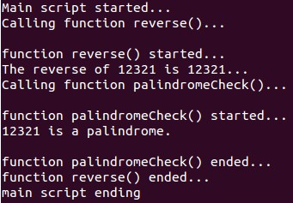

1. Write a shell script which reads a number from the user and passes it to function named factorial(). This function finds the factorial of the number and prints it on the terminal.

**Sample Output:**

